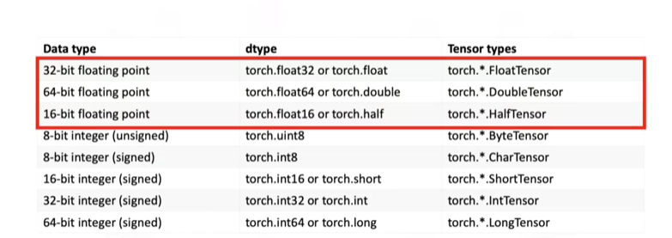

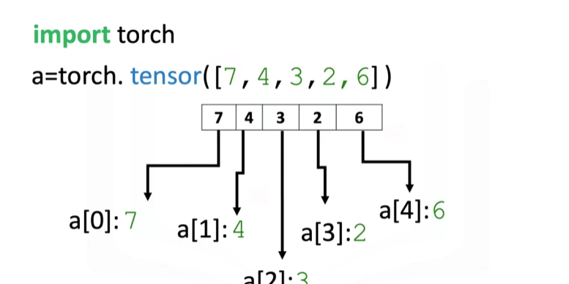

**DTYPE AND TYPE**

1. Dtype return the data type tensor have
2. Type return the type of tensor

EX1:

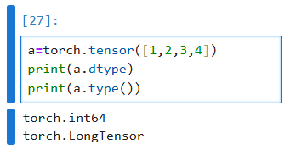

EX 2:

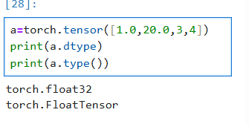

**Defining dtype –** It will change any type of tensor to the specified type

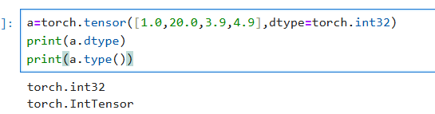

**Creating tensor with specific type**

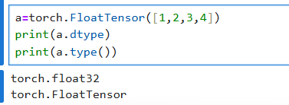

**Specifying type inside type()**

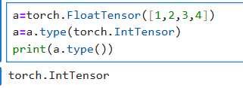

**Size(), nDimension() method**

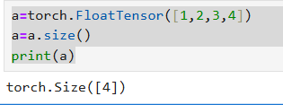

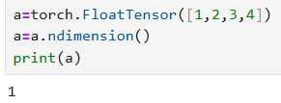

**View() method**

Helps to change 1 diamension array to specified dimension array.

**Syntax:** view(no_of_row, no_of_column)

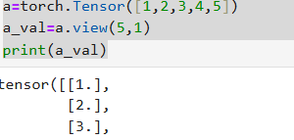

If the specified no of row is not equal to the actual size of tensor then we will got error. In this case we will use -1 on that place

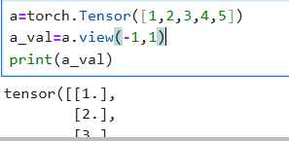

**CHANGING NUMPY ARRAY TO TENSORS, TENSORS TO NUMPY**

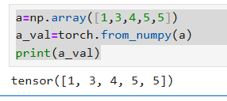

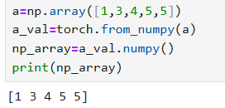

**CREATNG TENSORS FROM PANDAS SERIES**

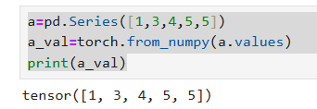

**ToList()** – convert tensors to list

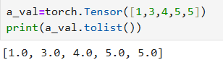

**Item() method**

Each number inside tensor are considered as tensor, some times we want to get the actual number instead of tensor, that I what item does

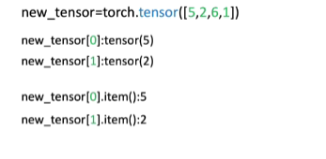

**SLICING:**

Tensors can be sliced like as array and the items inside tensors can be changed by it’s index

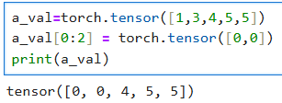

**BASIC TENSOR OPERATIONS**

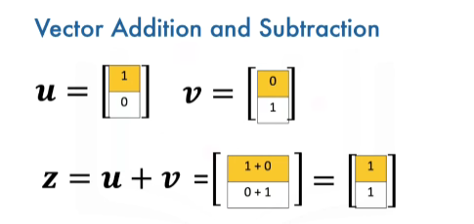

**Element wise add**

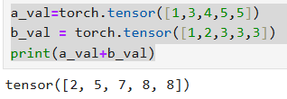

No of elements in one tensor should equal to the other tensor to do the above one

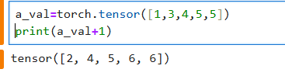

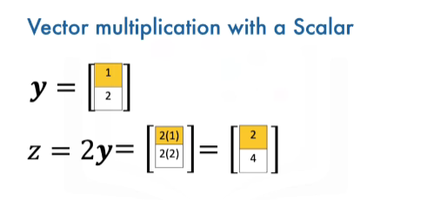

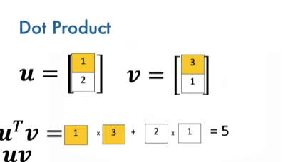

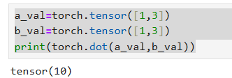

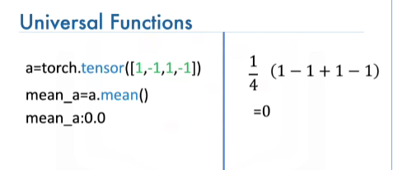

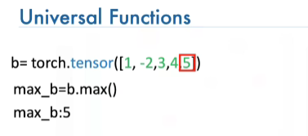

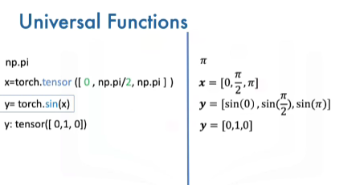

**Linspace –** Gives evenly separated values from starting and ending number

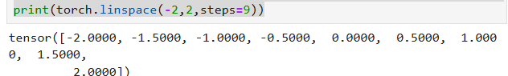

**PLOTTING**

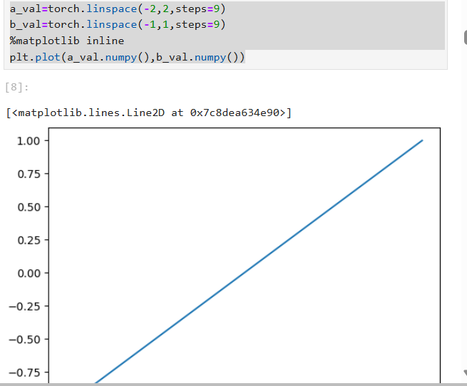

**CREATING TENSORS USING RANDN**

input_tensor = torch.randn(size=(1, 3, 224, 224))

print("Input shape:", input_tensor.shape)

The tensor will have **4 dimensions**: (1, 3, 224, 224).

Here's what each dimension typically represents in computer vision tasks:

* **Batch size (1):** The number of images in the batch.
* **Channels (3):** The number of color channels (e.g., RGB has 3 channels).
* **Height (224):** The height of the image in pixels.
* **Width (224):** The width of the image in pixels.